If you still need assistance after following the previous steps, you can contact the Minnesota Attorney General’s office at (651) 296-3353 or 1-800-657-3787 and the U.S. Department of Labor at 1-866-444-3272 to see if they can assist you with your specific issue.
(Info from MN Department of Health)

750 S Plaza Dr, Ste 207
Mendota Heights, MN 55120
Phone: 651-406-8655
Fax: 651-406-8656
www.hfmd.org

Appeals & Complaints in Minnesota
To issue complaints about Health Insurance Carriers or Health Maintenance Organizations (HMOs) and/or their providers the following steps can be made:
- Call the member/customer services phone number on the back of your member card. You have the right to submit a complaint orally or in writing. If your oral complaint is not resolved to your satisfaction, you can submit a written complaint. In either case, you have the right to appeal a complaint decision that does not satisfy you.
- If you are enrolled in an HMO, call the Minnesota Department of Health, Managed Care Systems section at (651) 201-5100 or 1-800-657-3916 to file a complaint. The complaint form can be sent to you or you can find it online at www.health.state.mn.us/hmo.
- If you are covered by a health carrier that is not an HMO, call the Minnesota Department of Commerce Consumer Response Team at (651) 296-2488 or 1-800-657-3602. Look on the back of your health card to see if these phone numbers are listed there.
- If you are covered by a non-government self-insured group, the State has no authority to investigate your complaint. To register a complaint, contact the organization that takes care of employee claims. This number is usually on the back of your member card. You can also contact your employer.
Health Insurance Resources

Minnesota
North Dakota
South Dakota

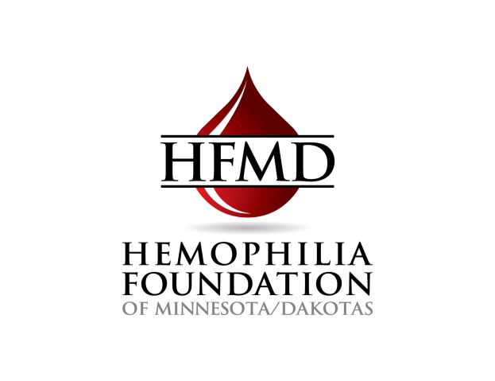

Minnesota

Private Insurance
Group
Offered through employer. Work with your employee human resource office to get available plan information and use the NHF Insurance Tool Kit to assist you in choosing between available plans.

Individual
You can choose to work with a licensed insurance agent who can make recommendations and help you purchase a health plan in the private insurance marketplace. Utilize the NHF Insurance Tool Kit to assist you in choosing a plan.

You can purchase health insurance through the MNSURE marketplace. Depending on income, insurance purchased through MNSURE may qualify for tax credits or cost sharing subsidies. You can use the NHF Insurance Tool Kit along with the resources below to assist you in choosing a plan.
MNSURE: www.mnsure.org;
1-855-366-7873

MNSURE Assistance: www.mnsure.org/individual-family/find-assister/index.jsp

Public Insurance
Medicaid
To apply for Medicaid/Medical Assistance you need to contact your County Social Service Office. The location for the office in your county can be found on the website for the Department of human services at www.dhs.state.mn.us under the "Healthcare" tab.
Other resources can be found through the MNSURE website at www.mnsure.org, or by calling them at 1-855-366-7873.

Minnesota Care
To apply contact the Minnesota Care Office:
In the Twin Cities metro area call: 651-297-3862
Toll free from outside Twin Cities: 1-800-657-3672

More information can also be found at the previously mentioned Social Services and MNSure sites.

Medicare
For more information and to apply start by calling: Medicare at 1-800-633-4227; or
Senior Linkage Line at 1-800-333-2433; or the
Disability Linkage Line 1-800-333-2466

For more information on Medicare policies you can find information at www.medicare.gov.

You can also find information on Medigap (Medicare Supplement policies) in your area by going to:
www.medicare.gov/find-a-plan/questions/medigap-home.aspx

North Dakota

Private Insurance
Group
Offered through employer. Work with your employee human resource office to get available plan information and use the NHF Insurance Tool Kit to assist you in choosing between available plans.

Individual
You can choose to work with a licensed insurance agent who can make recommendations and help you purchase a health plan in the private insurance marketplace, or utilize the NHF Insurance Tool Kit to assist you in choosing a plan.
You can also visit the Federal Insurance Exchange website at www.healthcare.gov/get-coverage/. Advocates at Family HealthCare in Fargo and Moorhead assist people with obtaining plans through the exchange. Call them at (701)271-3344.
Public Insurance:
Medicaid
Check with your county social service office for help with Medicaid. The location of your office can be obtained by visiting the ND Government Website at http://www.nd.gov/dhs/locations/countysocialserv/

Medicare
See information for Minnesota

South Dakota

Private Insurance
Group
Offered through employer. Work with your employee human resource office to get available plan information and use the NHF Insurance Tool Kit to assist you in choosing between available plans.
Individual
You can choose to work with a licensed insurance agent who can make recommendations and help you purchase a health plan in the private insurance marketplace. Utilize the NHF Insurance Tool Kit to assist you in choosing a plan. You can also visit the Feral Insurance Exchange at www.healthcare.gov/get-coverage/.

Public Insurance:
Medicaid
Call the South Dakota Medicaid Office at (605)773-3165.

Travel Reimbursement can also be requested by calling the SD Medicaid Travel Reimbursement Line at (605)773-6527 / (866)403-1433.

Medicare
See information for Minnesota.

