The HFMD is a non-profit organization dedicated to providing programs and services for those living with hemophilia and related genetic bleeding disorders.

**Hemophilia Federation of America’s Helping Hands Program**

* Provides emergency assistance for people experiencing financial crisis due to a bleeding disorder, which is available one time per year
* Reimbursement also provided for qualifying items including, but not limited to protective gear, braces and supports, walking supports, and heating/cooling Items
* Program Info: [www.hemophiliafed.org/programs/helping-hands](www.hemophiliafed.org/programs/helping-hands%20)

**Colburn Keenan Foundation**

* Provides funding to assist with socio-economic and insurance needs
* Program Info: <www.colkeen.org>

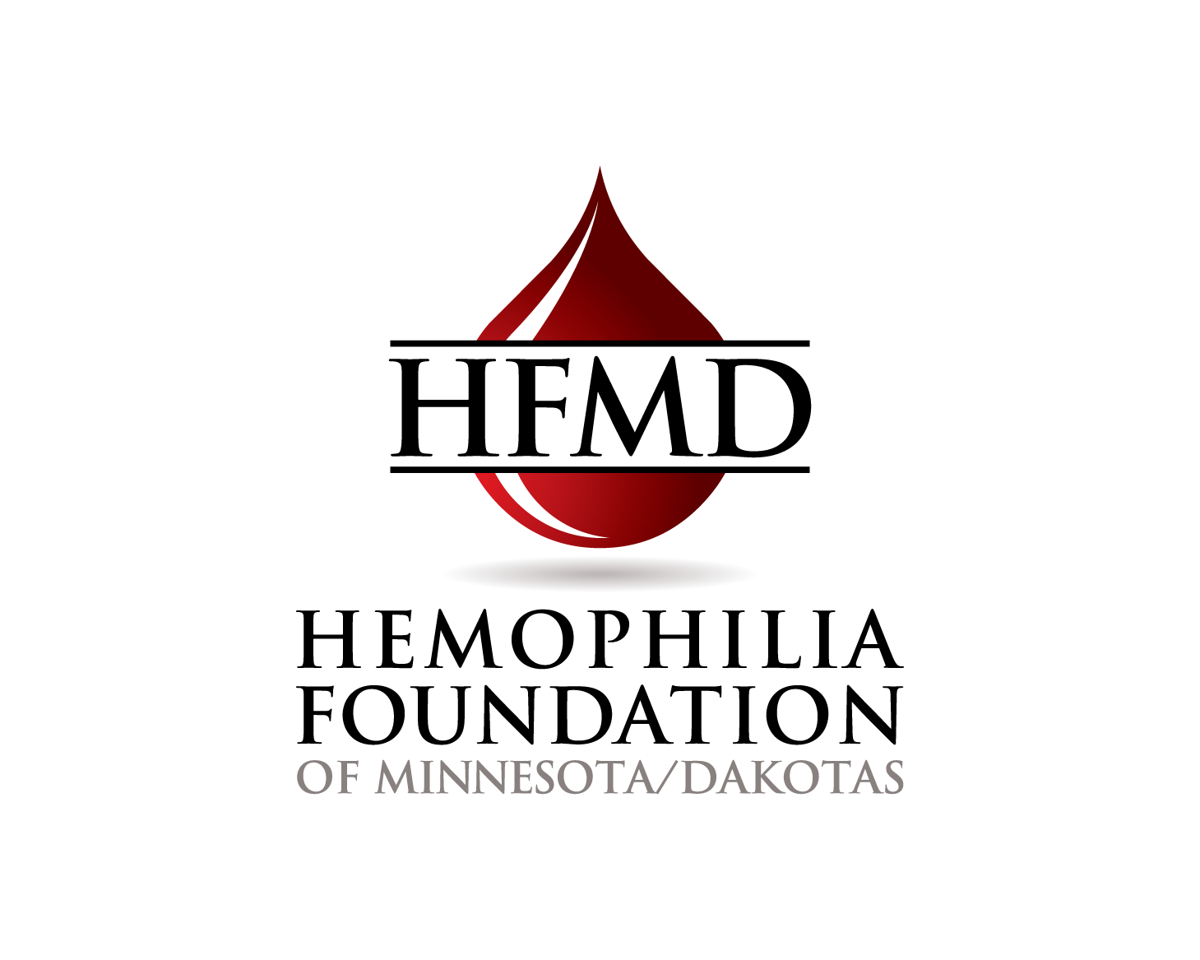

**Other Resources**

**PSI Programs**

**Patient Services Inc. (PSI)**

**Premium Assistance**

**For Hemophilia and von Willebrand Disease Patients**

* Annual cap of $11,000
* Eligibility requirements: Must have diagnosis of hemophilia or VWD
* Must be below PSI’s 350% FPL sliding scale (based on state – high or low income)
* Must have health insurance)
* Assistance available for up to 3 years
* Program info: <www.patientservicesinc.org/For-Patients/Supported-Illnesses> or 1-800-366-7741

**For Inhibitor Patients**

* Must be below PSI’s 400% FPL sliding scale (based on state)
* Annual cap of $11,000
* Assistance available for up to 2 years
* Eligibility requirements: Must have health insurance
* Program info: <www.patientservicesinc.org>



**Hemophilia Foundation of MN and Dakotas**

* Financial assistance may be available to persons with bleeding disorders to address a significant non-recurring financial hardship.
* The person requesting assistance must be an adult (or parent of a child) under the care of an HTC physician to verify a bleeding disorder
* Requests can be made through a social worker at one of the five Hemophilia Treatment Centers
* Areas of assistance include Transportation, Lodging, and non-covered heath care expenses

750 S Plaza Drive, Ste 207

Mendota Heights, MN 55120

Phone: (651) 406-8655

Fax: (651) 406-8656

Hemophilia Foundation of Minnesota/Dakotas

## Patient Assistance Programs

**In the event of loss of health insurance coverage, the above pharmaceutical companies may also have short-term patient assistance programs for their factor product if income and other eligibility criteria are met.   If you experience loss of health insurance, contact your hemophilia center social worker for assistance.**

**Biogen Idec (cont'd)**

**MyEloctate Co-pay Program – for ELOCTATE**

* Assists with monthly out-of-pocket costs for Eloctate up to $12,000 a year
* Eligibility Requirements:
  + - No income requirements or caps
    - Only applies to private insurance
    - Must have a U.S.-based prescriber and pharmacy
    - Other restrictions may apply
* Program Info: [www.eloctatepro.com/patient-resources](http://www.eloctatepro.com/patient-resources) or 1-855-693-5628

**CSL Behring**

**“My Access” Program – for HELIXATE FS & HUMATE P**

* May cover up to $12,000 of OOP expenses each year
* Eligibility Requirements:
  + - Must take a CSL Behring product for the treatment of von Willebrand disease or hemophilia A
    - Have private insurance (U.S. insurance)
* Program Info: [www.mysourcecsl.com](http://www.mysourcecsl.com) or

1-800-676-4266

**Grifols**

**Alphanate® or AlphaNine® SD Savings Card Program – for ALPHANATE & ALPHANINE**

Covers up to a maximum of $20,000 per year of coinsurance/copayment costs toward prescription drug cost for

* Alphanate [www.alphanatecard.com](http://www.alphanatecard.com);

(877) 255-4829

* Alphanine [www.alphaninecard.com](http://www.alphaninecard.com)

(877) 264-1405

* Program Info: [www.grifolspatientcare.com](http://www.grifolspatientcare.com/);

(888) 325-8579

**Novo Nordisk**

**NovoSecure™ : Personalized patient support for every step of life's journey**

At Novo Nordisk, we know you're on to the next great thing in your life, and we're here to help you get there.

**Novo Nordisk (cont'd)**

With NovoSecure™, you have access to strong support specifically designed for and inspired by the bleeding disorders community.

Program Info: [www.mynovosecure.com](www.mynovosecure.com%20) or

1-800-727-6500

**Pfizer**

**Factor Savings Card – for BENEFIX & XYNTHA**

* Offers up to $10,000 in co-pay, coinsurance or other OOP cost assistance
* Eligibility Requirements:
  + - Available to privately insured patients or uninsured
    - No financial eligibility requirements
* Program Info: [www.hemophiliavillage.com](http://www.hemophiliavillage.com/)

or 1-855-739-4366



**Bayer’s Kogenate®**

**FS Co-Pay/Coinsurance Assistance Program – for KOGENATE FS**

* Covers a patients out of pocket (OOP) expenses for Bayer’s Kogenate® FS for up to 12 months
* Eligibility Requirements:
  + - Must have private insurance
    - Need based – uses a sliding scale based on income
* Eligible members can receive up to $12,000/year
* Program Info: 1-800-288-8374

**Baxter**

**Co-Pay Assistance Program – for ADVATE, FEIBA, RECOMBINATE, & FEIBA**

* Covers a patients out of pocket (OOP) costs related to deductible, copayment, and coinsurance for eligible Baxter factor or bypass products. Non-medication expenses, such as ancillary supplies or administration-related costs, are not eligible.
* 100% of eligible OOP costs up to $12,000 every 12 months
* Eligibility Requirements:
  + - Must have a current prescription for an eligible Baxter factor or bypass product
    - Must have a diagnosis of Hemophilia A or B, or a hemophilia A or B inhibitor
    - Must have commercial insurance
* Enroll by calling 1-888-229-8379

**Biogen Idec**

**MyALPROLIX Co-pay Program – for ALPROLIX**

* Assists with Co-pay costs for Alprolix, and helps link patients to coverage resources
* Eligibility Requirements:
  + - No income requirements or caps
    - Only applies to private insurance
    - Must have a U.S.-based prescriber and pharmacy
    - Other limits may apply
* Program Info: [www.alprolixpro.com/patient-resources](http://www.alprolixpro.com/patient-resources) or 1-855-692-5776

**INDUSTRY RESOURCES**